Capstone Project Report

On

“**LEAVE MANAGEMNT SYSTEM”**

Submitted by:

**Name:** Ritik Saini, Mukinda Vishnu Patare, Pratiksha Nigudkar,Prashant Kumar Singh, Vishal Vinod Gangurde.

**Batch** Axis Bank School of Java Batch 2

**LMS Id:** MGSA_060, MGSA_425, MGSA_058, MGSA_061, MGSA_418.

**Date:** 05/01/2023

**Table of contents**

1. Abstract………………………………………………

2. Introduction…………………………………………...

3. Flow of the project……………………………………

4. Software Requirements……………………………….

5. Screen shots………………………………………….

6.Future enhancements………………………………….

7. References…………………………………………….

**Abstract**

The purpose of Leave Management System is to design a website which will be helpful and provide an important role to maintain the leave management of the employees by their respective managers.

Leave Management System is an error free, reliable, fast and secure internet based application that can be used for helping the organization to maintain and manage employees, leaves and projects.

The aim of Leave Management System is to automate the whole system so that the valuable data can be stored for a longer period with easy access and manipulation.

Basically the Project focuses on how to manage for good performance and better services for the employees by providing functionalities like Employee Management, Project Management and Leave Management.

**Introduction**

The Leave Management System is a error free, secure, reliable and fast management system website which enables employees to perform several operations for an organization like Employee Management, Project Management and Leave Management.

The purpose of this application is to build a program to reduce manual work by decreasing the paperwork and helping in easy record maintenance by having a particular database system where employee details, project details and leaves details are maintained.

The application is very user friendly as no formal knowledge is needed for using the functionalities. The Leave Management System is customized as per the functionalities required by admin, employee as well as manager for a smooth and better experience for users.

The Employees of the organization can use the functionality of leave management which makes it easy for them to request and track their leaves. The HR or admin has additional access to functionalities which helps balancing workload by maintaining details of the employees, better management of resources and to use them effectively and efficiently. The leaves can be approved by the managers of the respective departments for the employees according to their organization's policy.

**Flow of the Project**

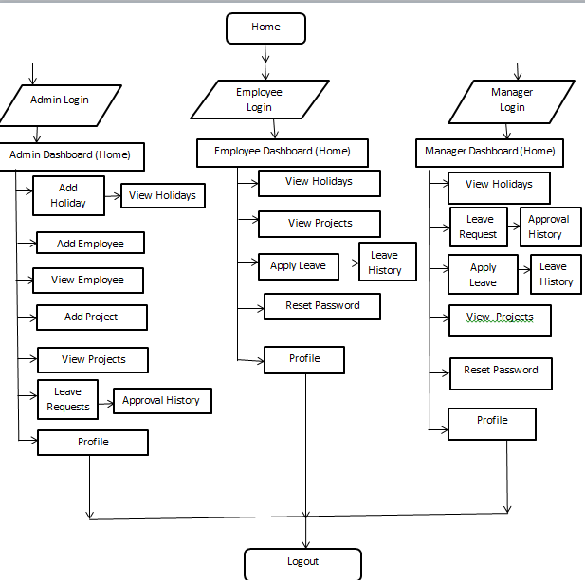

**Flow of the Project**

The flow of project can be defined in 3 point of views

1. **Employee**
2. **Admin**
3. **Manager**

**1.** Taking the employee point of view we have given the many options to employee as they can see:

* DASHBOARD
* VIEW HOLIDAY
* VIEW PROJECT
* APPLY LEAVE
* VIEW LEAVE HISTORY
* RESET PASSWORD
* PROFILE

**2.** Taking the admin point of view we have given the many options to admin as they can see:

* DASHBOARD
* VIEW HOLIDAY
* ADD EMPLOYEE
* VIEW EMPLOYEE
* ADD PROJECT
* VIEW PROJECT
* LEAVE REQUESTS(MANAGER)

A. Approve leave request

B. Reject leave request

* RESET PASSWORD
* PROFILE

**Flow of the Project**

**3.** Taking the manager point of view we have given the many options to manager as they can see:

* DASHBOARD
* VIEW HOLIDAY
* EMPLOYEE DETAILS
* LEAVE REQUESTS

1. Approve leave request
2. Reject leave request

* VIEW PROJECTS
* RESET PASSWORD
* PROFILE

As we have discussed above we knew the various features according to admin, employee, and manager perspectives. And on the flow chart we can define all features through a flow chart which will show various functions.

**Software Requirements**

For the fastest and most stable experience, we recommend:

* An Octane 2.0 score of 30,000 or greater
* Network latency of 150 ms or less
* Download speed of 3 Mbps or greater
* At least 8 GB of RAM, with 3 GB available for Salesforce browser tabs

Minimum requirements are:

* An Octane 2.0 score of 20,000 or greater
* Network latency of 200 ms or less
* Download speed of 1 Mbps or greater
* At least 4 GB of RAM, with 2 GB available for Salesforce browser tabs

**OR**

|  |  |
| --- | --- |
| **Requirements** | |
| **Windows** | | |
| **Operating system** | [Windows 8.1](https://en.wikipedia.org/wiki/Windows_8.1) 64-bit, [Windows 8](https://en.wikipedia.org/wiki/Windows_8) 64-bit, Windows 7 Service Pack 1 64-bit, Windows Vista Service Pack 2 64-bit | |
| **CPU** | [Core 2 Quad](https://en.wikipedia.org/wiki/Core_2_Quad) Q6600 at 2.4 GHz or [AMD Phenom](https://en.wikipedia.org/wiki/AMD_Phenom) 9850 at 2.5 GHz | |
| **Memory** | 4 GB [RAM](https://en.wikipedia.org/wiki/Random_Access_Memory) | |
| **Free space** | 65 GB of free space | |
| **Tools and Technologies** | Eclipse Workspace, Oracle DB, Spring Boot | |
| **Languages** | Java, HTML, CSS, JavaScript, | |

**Screen shots**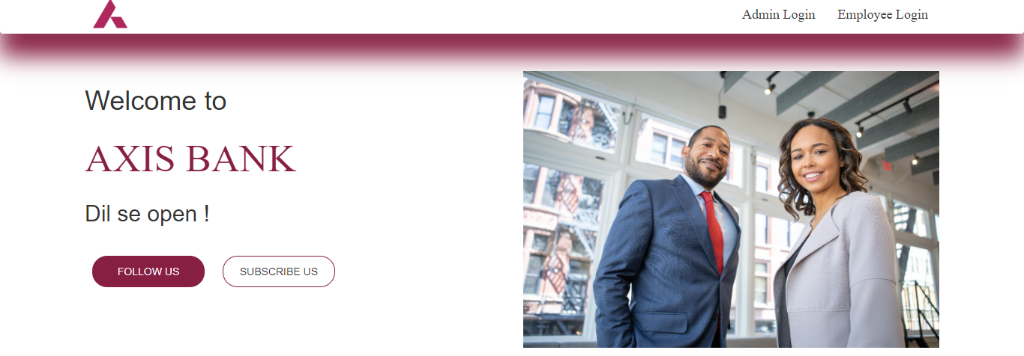

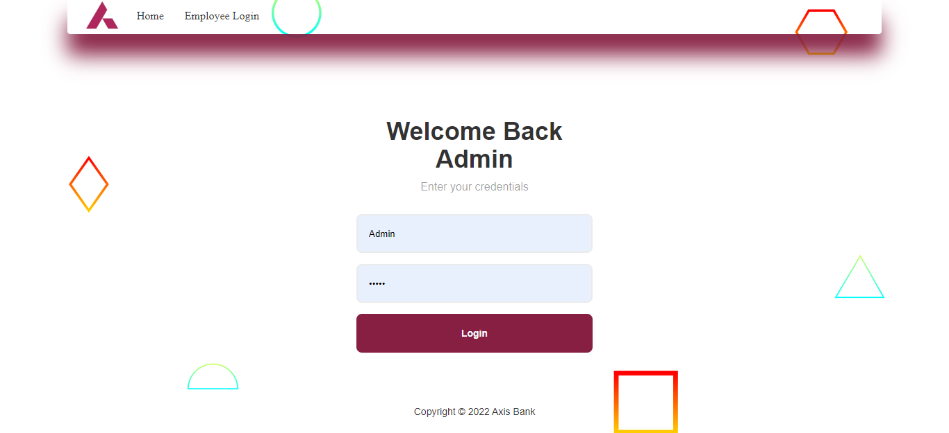

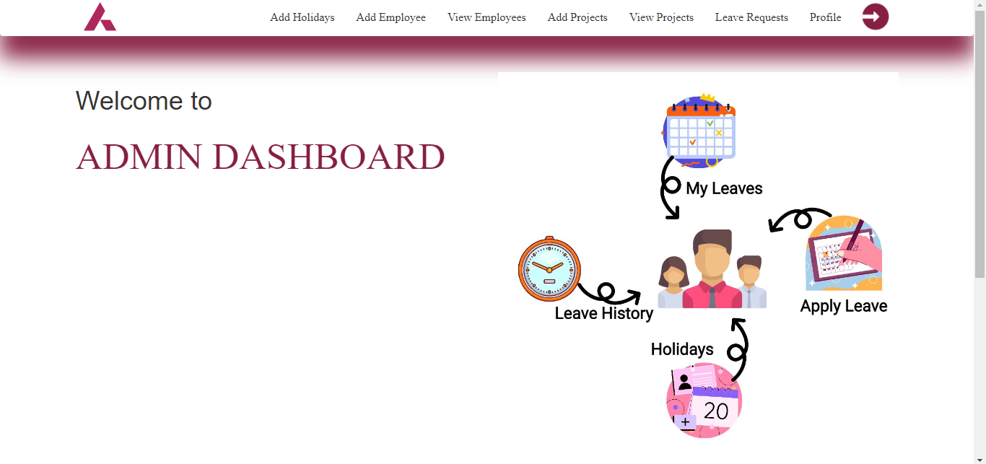

**Screen shots**

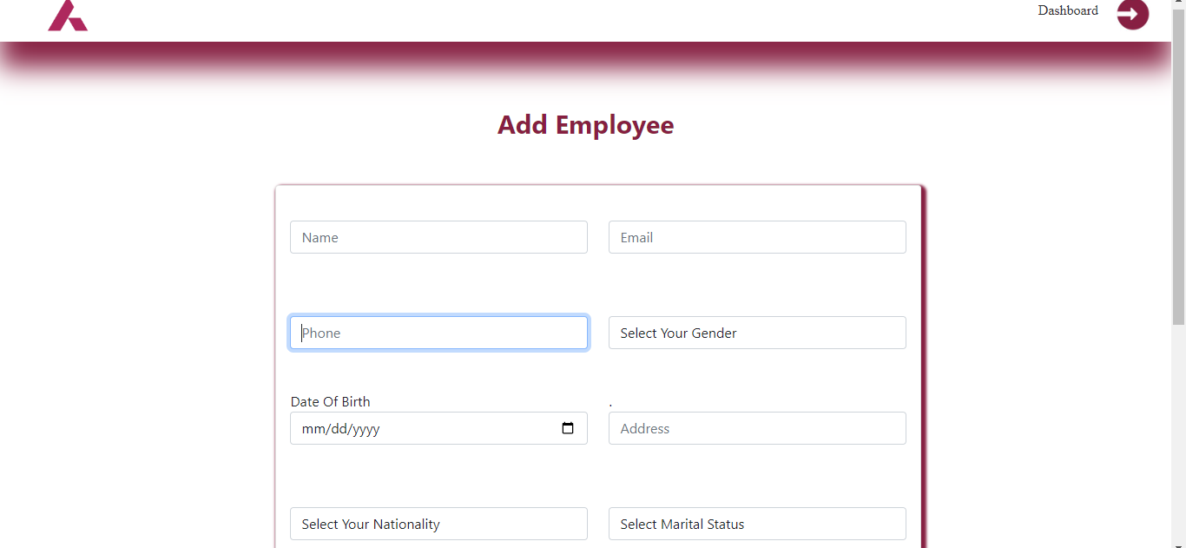

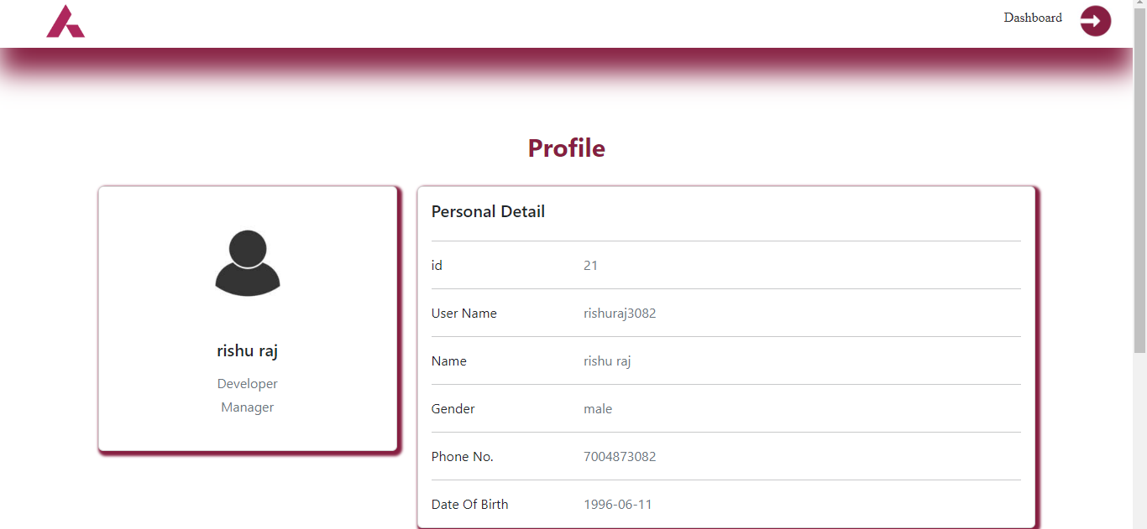

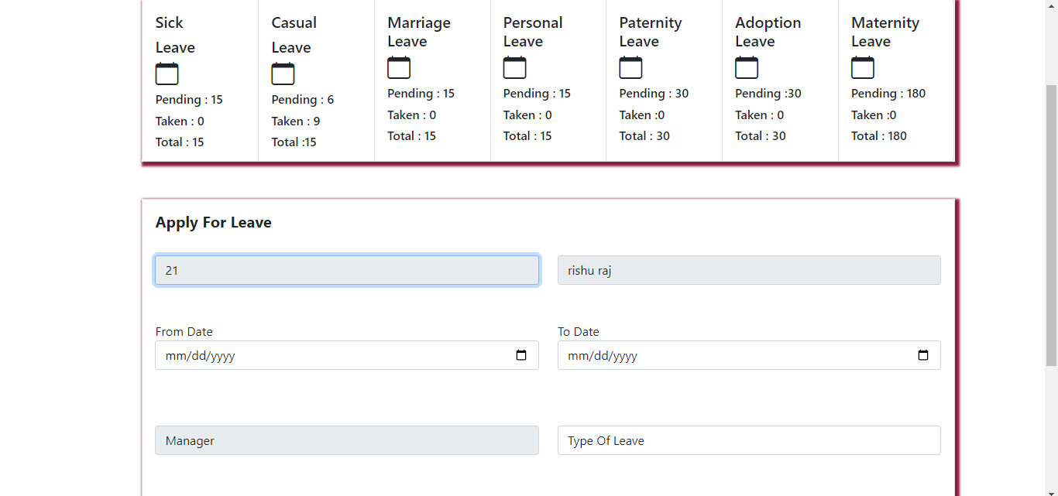

**Screen shots**

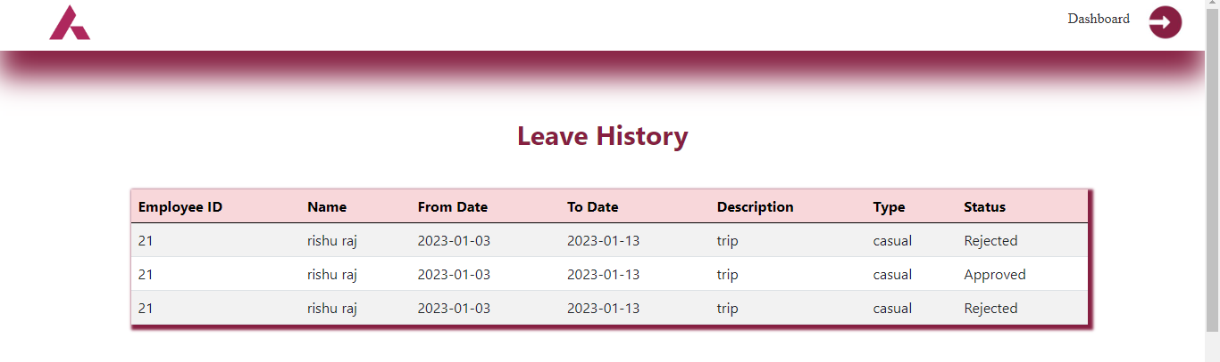

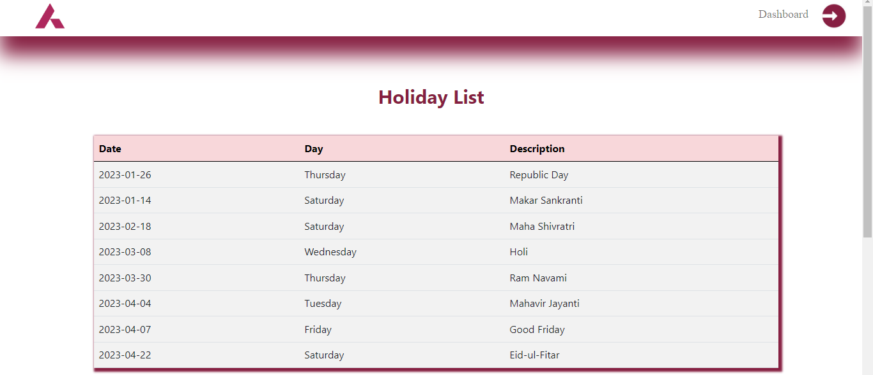

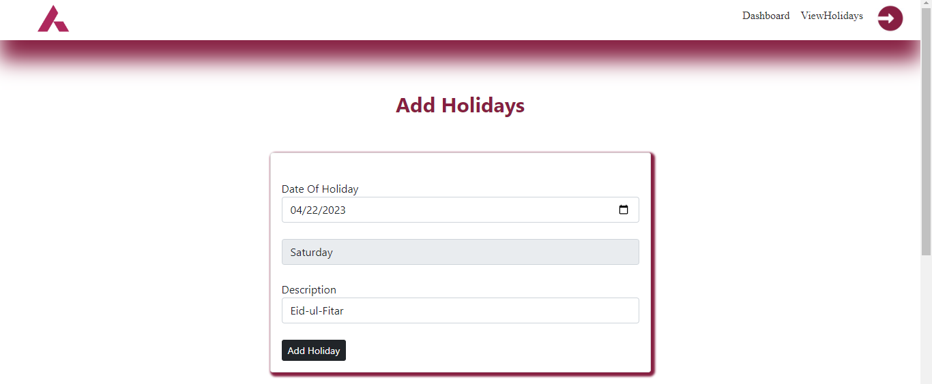

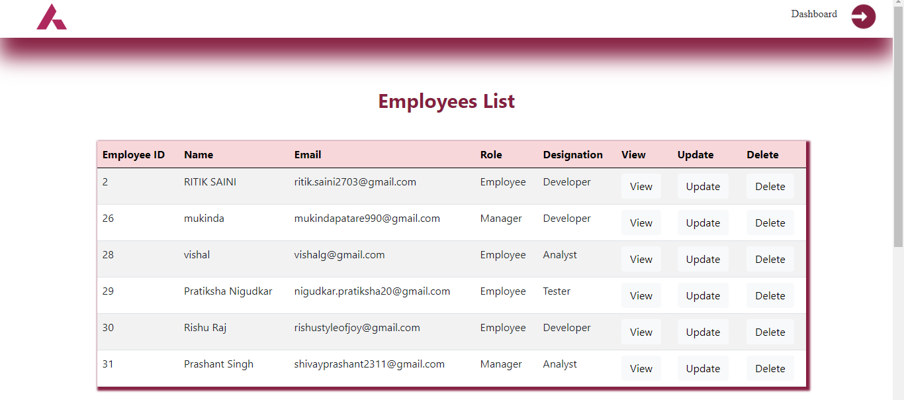

**Future Enhancements**

* 1. In today’s mobility-driven workplace with concepts supporting REMOTE the centralized database system must be cloud compliant. They offer cross-platform operability, and GUI retrieved data that is accessible from any electronic device such as mobile, laptops, desktops through wired or wireless connectivity.
  2. The LMS provides end-to-end automation of the entire leave process, saving significant time and cost. It offers the real-time status of leaves available, prompts leave application status at various managerial levels to management, the employee, and peers governed by access rights and respective leave policy.
  3. The AI tool offers the capability to integrate with biometric devices and record attendance.
  4. A leave management system can automate leave calculations and offer error-free data for use in other applications, such as calculating Loss of Pay or running payroll.
  5. Employers can easily set leave policies for the organization from any location.

**References**

1. Google for problem solving.
2. https://www.getbootstrap.com.
3. Database Programming with JDBC and Java by O'Reilly.
4. http://www.jdbc-tutorial.com.
5. https://www.tutorialspoint.com/java.
6. https://docs.oracle.com/javase/tutorial.
7. http://www.tutorialspoint.com/mysql.
8. https://www.zoho.com/people.

**GitHub link=https://github.com/ritiksaini2703/Leave-Management-System.git**